OOAD:
Patterns: MOST importantly: (FACADE, SINGLETON, FACTORY, ABSTRACT FACTORY, OBSERVER).
In software development, a pattern (or design pattern) is a written document that describes a general solution to a design problem that recurs repeatedly in many projects. Software designers adapt the pattern solution to their specific project. Patterns use a formal approach to describing a design problem, its proposed solution, and any other factors that might affect the problem or the solution. A successful pattern should have established itself as leading to a good solution in three previous projects or situations.
In object-oriented programming, a pattern can contain the description of certain objects and object classes to be used, along with their attributes and dependencies, and the general approach to how to solve the problem. Often, programmers can use more than one pattern to address a specific problem. A collection of patterns is called a pattern framework.

What is Gang of Four (GOF)?
In 1994, four authors Erich Gamma, Richard Helm, Ralph Johnson und John Vlissides published a book titled Design Patterns - Elements of Reusable Object-Oriented Software which initiated the concept of Design Pattern in Software development.
These authors are collectively known as Gang of Four (GOF). According to these authors design patterns are primarily based on the following principles of object orientated design.
- Program to an interface not an implementation
- Favor object composition over inheritance

Factory Pattern
Factory pattern is one of the most used design patterns in Java. This type of design pattern comes under creational pattern as this pattern provides one of the best ways to create an object.
In Factory pattern, we create object without exposing the creation logic to the client and refer to newly created object using a common interface.

Implementation
We're going to create a Shape interface and concrete classes implementing the Shape interface. A factory class ShapeFactory is defined as a next step.
FactoryPatternDemo, our demo class will use ShapeFactory to get a Shape object. It will pass information (CIRCLE / RECTANGLE / SQUARE) to ShapeFactory to get the type of object it needs.
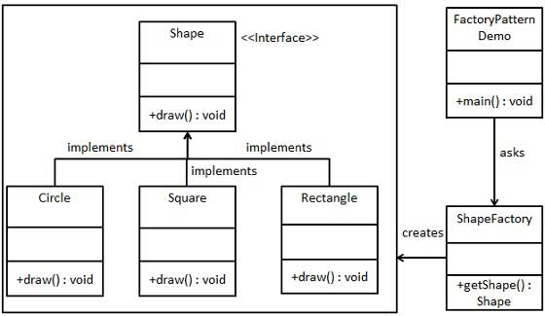

Step 1
Create an interface.
Shape.java
public interface Shape {
void draw();
}

Step 2
Create concrete classes implementing the same interface.
Rectangle.java
public class Rectangle implements Shape {

@Override
public void draw() {
System.out.println("Inside Rectangle::draw() method.");
}
}
Square.java
public class Square implements Shape {

@Override
public void draw() {
System.out.println("Inside Square::draw() method.");
}
}
Circle.java
public class Circle implements Shape {

@Override
public void draw() {
System.out.println("Inside Circle::draw() method.");
}
}

Step 3
Create a Factory to generate object of concrete class based on given information.
ShapeFactory.java
public class ShapeFactory {

//use getShape method to get object of type shape
public Shape getShape(String shapeType){
if(shapeType == null){
return null;
}
if(shapeType.equalsIgnoreCase("CIRCLE")){
return new Circle();
} else if(shapeType.equalsIgnoreCase("RECTANGLE")){
return new Rectangle();
} else if(shapeType.equalsIgnoreCase("SQUARE")){
return new Square();
}
return null;
}
}

Step 4
Use the Factory to get object of concrete class by passing an information such as type.
FactoryPatternDemo.java
public class FactoryPatternDemo {

public static void main(String[] args) {
ShapeFactory shapeFactory = new ShapeFactory();

//get an object of Circle and call its draw method.
Shape shape1 = shapeFactory.getShape("CIRCLE");

//call draw method of Circle
shape1.draw();

//get an object of Rectangle and call its draw method.
Shape shape2 = shapeFactory.getShape("RECTANGLE");

//call draw method of Rectangle
shape2.draw();

//get an object of Square and call its draw method.
Shape shape3 = shapeFactory.getShape("SQUARE");

//call draw method of circle
shape3.draw();
}
}

Step 5
Verify the output.
Inside Circle::draw() method.
Inside Rectangle::draw() method.
Inside Square::draw() method.

Abstract Factory Pattern
Abstract Factory patterns works around a super-factory which creates other factories. This factory is also called as Factory of factories. This type of design pattern comes under creational pattern as this pattern provides one of the best ways to create an object.
In Abstract Factory pattern an interface is responsible for creating a factory of related objects, without explicitly specifying their classes. Each generated factory can give the objects as per the Factory pattern.

Implementation
We're going to create a Shape and Color interfaces and concrete classes implementing these interfaces. We creates an abstract factory class AbstractFactory as next step. Factory classes ShapeFactory and ColorFactory are defined where each factory extends AbstractFactory. A factory creator/generator class FactoryProducer is created.
AbstractFactoryPatternDemo, our demo class uses FactoryProducer to get a AbstractFactory object. It will pass information (CIRCLE / RECTANGLE / SQUARE for Shape) to AbstractFactory to get the type of object it needs. It also passes information (RED / GREEN / BLUE for Color) to AbstractFactory to get the type of object it needs.
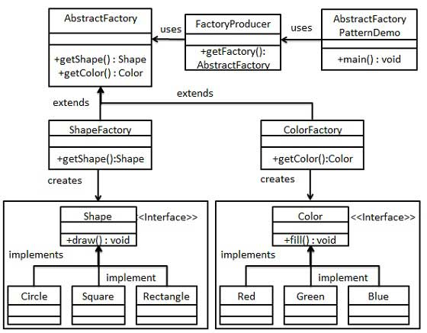

Step 1
Create an interface for Shapes.
Shape.java
public interface Shape {
void draw();
}

Step 2
Create concrete classes implementing the same interface.
Rectangle.java
public class Rectangle implements Shape {

@Override
public void draw() {
System.out.println("Inside Rectangle::draw() method.");
}
}
Square.java
public class Square implements Shape {

@Override
public void draw() {
System.out.println("Inside Square::draw() method.");
}
}
Circle.java
public class Circle implements Shape {

@Override
public void draw() {
System.out.println("Inside Circle::draw() method.");
}
}

Step 3
Create an interface for Colors.
Color.java
public interface Color {
void fill();
}

Step4
Create concrete classes implementing the same interface.
Red.java
public class Red implements Color {

@Override
public void fill() {
System.out.println("Inside Red::fill() method.");
}
}
Green.java
public class Green implements Color {

@Override
public void fill() {
System.out.println("Inside Green::fill() method.");
}
}
Blue.java
public class Blue implements Color {

@Override
public void fill() {
System.out.println("Inside Blue::fill() method.");
}
}

Step 5
Create an Abstract class to get factories for Color and Shape Objects.
AbstractFactory.java
public abstract class AbstractFactory {
abstract Color getColor(String color);
abstract Shape getShape(String shape) ;
}

Step 6
Create Factory classes extending AbstractFactory to generate object of concrete class based on given information.
ShapeFactory.java
public class ShapeFactory extends AbstractFactory {

@Override
public Shape getShape(String shapeType){
if(shapeType == null){
return null;
}
if(shapeType.equalsIgnoreCase("CIRCLE")){
return new Circle();
} else if(shapeType.equalsIgnoreCase("RECTANGLE")){
return new Rectangle();
} else if(shapeType.equalsIgnoreCase("SQUARE")){
return new Square();
}
return null;
}

@Override
Color getColor(String color) {
return null;
}
}
ColorFactory.java
public class ColorFactory extends AbstractFactory {

@Override
public Shape getShape(String shapeType){
return null;
}

@Override
Color getColor(String color) {
if(color == null){
return null;
}
if(color.equalsIgnoreCase("RED")){
return new Red();
} else if(color.equalsIgnoreCase("GREEN")){
return new Green();
} else if(color.equalsIgnoreCase("BLUE")){
return new Blue();
}
return null;
}
}

Step 7
Create a Factory generator/producer class to get factories by passing an information such as Shape or Color
FactoryProducer.java
public class FactoryProducer {
public static AbstractFactory getFactory(String choice){
if(choice.equalsIgnoreCase("SHAPE")){
return new ShapeFactory();
} else if(choice.equalsIgnoreCase("COLOR")){
return new ColorFactory();
}
return null;
}
}

Step 8
Use the FactoryProducer to get AbstractFactory in order to get factories of concrete classes by passing an information such as type.
AbstractFactoryPatternDemo.java
public class AbstractFactoryPatternDemo {
public static void main(String[] args) {

//get shape factory
AbstractFactory shapeFactory = FactoryProducer.getFactory("SHAPE");

//get an object of Shape Circle
Shape shape1 = shapeFactory.getShape("CIRCLE");

//call draw method of Shape Circle
shape1.draw();

//get an object of Shape Rectangle
Shape shape2 = shapeFactory.getShape("RECTANGLE");

//call draw method of Shape Rectangle
shape2.draw();

//get an object of Shape Square
Shape shape3 = shapeFactory.getShape("SQUARE");

//call draw method of Shape Square
shape3.draw();

//get color factory
AbstractFactory colorFactory = FactoryProducer.getFactory("COLOR");

//get an object of Color Red
Color color1 = colorFactory.getColor("RED");

//call fill method of Red
color1.fill();

//get an object of Color Green
Color color2 = colorFactory.getColor("Green");

//call fill method of Green
color2.fill();

//get an object of Color Blue
Color color3 = colorFactory.getColor("BLUE");

//call fill method of Color Blue
color3.fill();
}
}

Step 9
Verify the output.
Inside Circle::draw() method.
Inside Rectangle::draw() method.
Inside Square::draw() method.
Inside Red::fill() method.
Inside Green::fill() method.
Inside Blue::fill() method.

Singleton Pattern
Singleton pattern is one of the simplest design patterns in Java. This type of design pattern comes under creational pattern as this pattern provides one of the best way to create an object.
This pattern involves a single class which is responsible to creates own object while making sure that only single object get created. This class provides a way to access its only object which can be accessed directly without need to instantiate the object of the class.

Implementation
We're going to create a SingleObject class. SingleObject class have its constructor as private and have a static instance of itself.
SingleObject class provides a static method to get its static instance to outside world. SingletonPatternDemo, our demo class will use SingleObject class to get a SingleObject object.
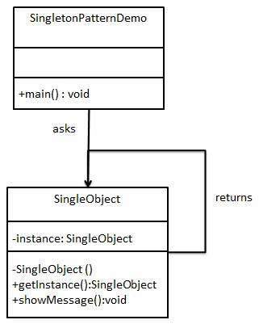

Step 1
Create a Singleton Class.
SingleObject.java
public class SingleObject {

//create an object of SingleObject
private static SingleObject instance = new SingleObject();

//make the constructor private so that this class cannot be
//instantiated
private SingleObject(){}

//Get the only object available
public static SingleObject getInstance(){
return instance;
}

public void showMessage(){
System.out.println("Hello World!");
}
}

Step 2
Get the only object from the singleton class.
SingletonPatternDemo.java
public class SingletonPatternDemo {
public static void main(String[] args) {

//illegal construct
//Compile Time Error: The constructor SingleObject() is not visible
//SingleObject object = new SingleObject();

//Get the only object available
SingleObject object = SingleObject.getInstance();

//show the message
object.showMessage();
}
}

Step 3
Verify the output.
Hello World!

Adapter Pattern
Adapter pattern works as a bridge between two incompatible interfaces. This type of design pattern comes under structural pattern as this pattern combines the capability of two independent interfaces.
This pattern involves a single class which is responsible to join functionalities of independent or incompatible interfaces. A real life example could be a case of card reader which acts as an adapter between memory card and a laptop. You plugins the memory card into card reader and card reader into the laptop so that memory card can be read via laptop.
We are demonstrating use of Adapter pattern via following example in which an audio player device can play mp3 files only and wants to use an advanced audio player capable of playing vlc and mp4 files.

Implementation
We've an interface MediaPlayer interface and a concrete class AudioPlayer implementing the MediaPlayer interface. AudioPlayer can play mp3 format audio files by default.
We're having another interface AdvancedMediaPlayer and concrete classes implementing the AdvancedMediaPlayer interface.These classes can play vlc and mp4 format files.
We want to make AudioPlayer to play other formats as well. To attain this, we've created an adapter class MediaAdapter which implements the MediaPlayer interface and uses AdvancedMediaPlayer objects to play the required format.
AudioPlayer uses the adapter class MediaAdapter passing it the desired audio type without knowing the actual class which can play the desired format. AdapterPatternDemo, our demo class will use AudioPlayer class to play various formats.
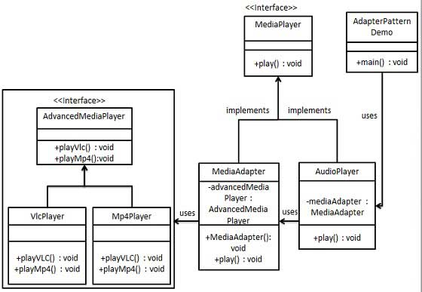

Step 1
Create interfaces for Media Player and Advanced Media Player.
MediaPlayer.java
public interface MediaPlayer {
public void play(String audioType, String fileName);
}
AdvancedMediaPlayer.java
public interface AdvancedMediaPlayer {
public void playVlc(String fileName);
public void playMp4(String fileName);
}

Step 2
Create concrete classes implementing the AdvancedMediaPlayer interface.
VlcPlayer.java
public class VlcPlayer implements AdvancedMediaPlayer{
@Override
public void playVlc(String fileName) {
System.out.println("Playing vlc file. Name: "+ fileName);
}

@Override
public void playMp4(String fileName) {
//do nothing
}
}
Mp4Player.java
public class Mp4Player implements AdvancedMediaPlayer{

@Override
public void playVlc(String fileName) {
//do nothing
}

@Override
public void playMp4(String fileName) {
System.out.println("Playing mp4 file. Name: "+ fileName);
}
}

Step 3
Create adapter class implementing the MediaPlayer interface.
MediaAdapter.java
public class MediaAdapter implements MediaPlayer {

AdvancedMediaPlayer advancedMusicPlayer;

public MediaAdapter(String audioType){
if(audioType.equalsIgnoreCase("vlc") ){
advancedMusicPlayer = new VlcPlayer();
} else if (audioType.equalsIgnoreCase("mp4")){
advancedMusicPlayer = new Mp4Player();
}
}

@Override
public void play(String audioType, String fileName) {
if(audioType.equalsIgnoreCase("vlc")){
advancedMusicPlayer.playVlc(fileName);
}else if(audioType.equalsIgnoreCase("mp4")){
advancedMusicPlayer.playMp4(fileName);
}
}
}

Step 4
Create concrete class implementing the MediaPlayer interface.
AudioPlayer.java
public class AudioPlayer implements MediaPlayer {
MediaAdapter mediaAdapter;

@Override
public void play(String audioType, String fileName) {

//inbuilt support to play mp3 music files
if(audioType.equalsIgnoreCase("mp3")){
System.out.println("Playing mp3 file. Name: "+ fileName);
}
//mediaAdapter is providing support to play other file formats
else if(audioType.equalsIgnoreCase("vlc")
|| audioType.equalsIgnoreCase("mp4")){
mediaAdapter = new MediaAdapter(audioType);
mediaAdapter.play(audioType, fileName);
}
else{
System.out.println("Invalid media. "+
audioType + " format not supported");
}
}
}

Step 5
Use the AudioPlayer to play different types of audio formats.
AdapterPatternDemo.java
public class AdapterPatternDemo {
public static void main(String[] args) {
AudioPlayer audioPlayer = new AudioPlayer();

audioPlayer.play("mp3", "beyond the horizon.mp3");
audioPlayer.play("mp4", "alone.mp4");
audioPlayer.play("vlc", "far far away.vlc");
audioPlayer.play("avi", "mind me.avi");
}
}

Step 6
Verify the output.
Playing mp3 file. Name: beyond the horizon.mp3
Playing mp4 file. Name: alone.mp4
Playing vlc file. Name: far far away.vlc
Invalid media. avi format not supported

Bridge Pattern
Bridge is used where we need to decouple an abstraction from its implementation so that the two can vary independently. This type of design pattern comes under structural pattern as this pattern decouples implementation class and abstract class by providing a bridge structure between them.
This pattern involves an interface which acts as a bridge which makes the functionality of concrete classes independent from interface implementer classes. Both types of classes can be altered structurally without affecting each other.
We are demonstrating use of Bridge pattern via following example in which a circle can be drawn in different colors using same abstract class method but different bridge implementer classes.

Implementation
We've an interface DrawAPI interface which is acting as a bridge implementer and concrete classes RedCircle, GreenCircle implementing the DrawAPI interface. Shape is an abstract class and will use object of DrawAPI. BridgePatternDemo, our demo class will use Shape class to draw different colored circle.
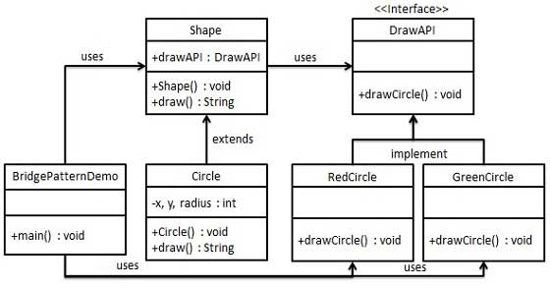

Step 1
Create bridge implementer interface.
DrawAPI.java
public interface DrawAPI {
public void drawCircle(int radius, int x, int y);
}

Step 2
Create concrete bridge implementer classes implementing the DrawAPI interface.
RedCircle.java
public class RedCircle implements DrawAPI {
@Override
public void drawCircle(int radius, int x, int y) {
System.out.println("Drawing Circle[ color: red, radius: "
+ radius +", x: " +x+", "+ y +"]");
}
}
GreenCircle.java
public class GreenCircle implements DrawAPI {
@Override
public void drawCircle(int radius, int x, int y) {
System.out.println("Drawing Circle[ color: green, radius: "
+ radius +", x: " +x+", "+ y +"]");
}
}

Step 3
Create an abstract class Shape using the DrawAPI interface.
Shape.java
public abstract class Shape {
protected DrawAPI drawAPI;
protected Shape(DrawAPI drawAPI){
this.drawAPI = drawAPI;
}
public abstract void draw();
}

Step 4
Create concrete class implementing the Shape interface.
Circle.java
public class Circle extends Shape {
private int x, y, radius;

public Circle(int x, int y, int radius, DrawAPI drawAPI) {
super(drawAPI);
this.x = x;
this.y = y;
this.radius = radius;
}

public void draw() {
drawAPI.drawCircle(radius,x,y);
}
}

Step 5
Use the Shape and DrawAPI classes to draw different colored circles.
BridgePatternDemo.java
public class BridgePatternDemo {
public static void main(String[] args) {
Shape redCircle = new Circle(100,100, 10, new RedCircle());
Shape greenCircle = new Circle(100,100, 10, new GreenCircle());

redCircle.draw();
greenCircle.draw();
}
}

Step 6
Verify the output.
Drawing Circle[ color: red, radius: 10, x: 100, 100]
Drawing Circle[ color: green, radius: 10, x: 100, 100]

Facade Pattern
Facade pattern hides the complexities of the system and provides an interface to the client using which the client can access the system. This type of design pattern comes under structural pattern as this pattern adds an interface to exiting system to hide its complexities.
This pattern involves a single class which provides simplified methods which are required by client and delegates calls to existing system classes methods.

Implementation
We're going to create a Shape interface and concrete classes implementing the Shape interface. A facade class ShapeMaker is defined as a next step.
ShapeMaker class uses the concrete classes to delegates user calls to these classes. FacadePatternDemo, our demo class will use ShapeMaker class to show the results.
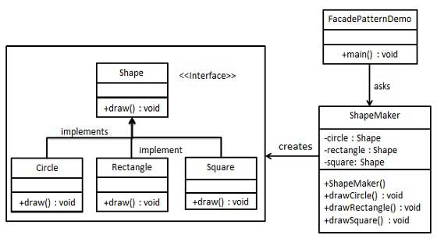

Step 1
Create an interface.
Shape.java
public interface Shape {
void draw();
}

Step 2
Create concrete classes implementing the same interface.
Rectangle.java
public class Rectangle implements Shape {

@Override
public void draw() {
System.out.println("Rectangle::draw()");
}
}
Square.java
public class Square implements Shape {

@Override
public void draw() {
System.out.println("Square::draw()");
}
}
Circle.java
public class Circle implements Shape {

@Override
public void draw() {
System.out.println("Circle::draw()");
}
}

Step 3
Create a facade class.
ShapeMaker.java
public class ShapeMaker {
private Shape circle;
private Shape rectangle;
private Shape square;

public ShapeMaker() {
circle = new Circle();
rectangle = new Rectangle();
square = new Square();
}

public void drawCircle(){
circle.draw();
}
public void drawRectangle(){
rectangle.draw();
}
public void drawSquare(){
square.draw();
}
}

Step 4
Use the facade to draw various types of shapes.
FacadePatternDemo.java
public class FacadePatternDemo {
public static void main(String[] args) {
ShapeMaker shapeMaker = new ShapeMaker();

shapeMaker.drawCircle();
shapeMaker.drawRectangle();
shapeMaker.drawSquare();
}
}

Step 5
Verify the output.
Circle::draw()
Rectangle::draw()
Square::draw()

Composite Pattern
Composite pattern is used where we need to treat a group of objects in similar way as a single object. Composite pattern composes objects in term of a tree structure to represent part as well as whole hierarchy . This type of design pattern comes under structural pattern as this pattern creates a tree structure of group of objects.
This pattern creates a class contains group of its own objects. This class provides ways to modify its group of same objects.
We are demonstrating use of Composite pattern via following example in which show employees hierarchy of an organization.

Implementation
We've a class Employee which acts as composite pattern actor class. CompositePatternDemo, our demo class will use Employee class to add department level hierarchy and print all employees.
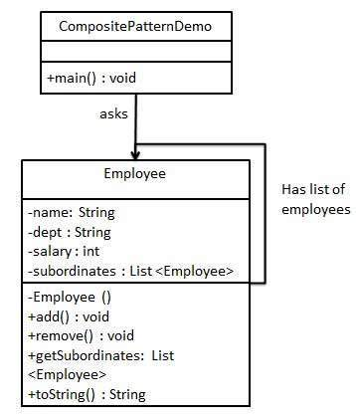

Step 1
Create Employee class having list of Employee objects.
Employee.java
import java.util.ArrayList;
import java.util.List;

public class Employee {
private String name;
private String dept;
private int salary;
private List<Employee> subordinates;

// constructor
public Employee(String name,String dept, int sal) {
this.name = name;
this.dept = dept;
this.salary = sal;
subordinates = new ArrayList<Employee>();
}

public void add(Employee e) {
subordinates.add(e);
}

public void remove(Employee e) {
subordinates.remove(e);
}

public List<Employee> getSubordinates(){
return subordinates;
}

public String toString(){
return ("Employee :[ Name : "+ name
+", dept : "+ dept + ", salary :"
+ salary+" ]");
}
}

Step 2
Use the Employee class to create and print employee hierarchy.
CompositePatternDemo.java
public class CompositePatternDemo {
public static void main(String[] args) {
Employee CEO = new Employee("John","CEO", 30000);

Employee headSales = new Employee("Robert","Head Sales", 20000);

Employee headMarketing = new Employee("Michel","Head Marketing", 20000);

Employee clerk1 = new Employee("Laura","Marketing", 10000);
Employee clerk2 = new Employee("Bob","Marketing", 10000);

Employee salesExecutive1 = new Employee("Richard","Sales", 10000);
Employee salesExecutive2 = new Employee("Rob","Sales", 10000);

CEO.add(headSales);
CEO.add(headMarketing);

headSales.add(salesExecutive1);
headSales.add(salesExecutive2);

headMarketing.add(clerk1);
headMarketing.add(clerk2);

//print all employees of the organization
System.out.println(CEO);
for (Employee headEmployee : CEO.getSubordinates()) {
System.out.println(headEmployee);
for (Employee employee : headEmployee.getSubordinates()) {
System.out.println(employee);
}
}
}
}

Step 3
Verify the output.
Employee :[ Name : John, dept : CEO, salary :30000 ]
Employee :[ Name : Robert, dept : Head Sales, salary :20000 ]
Employee :[ Name : Richard, dept : Sales, salary :10000 ]
Employee :[ Name : Rob, dept : Sales, salary :10000 ]
Employee :[ Name : Michel, dept : Head Marketing, salary :20000 ]
Employee :[ Name : Laura, dept : Marketing, salary :10000 ]
Employee :[ Name : Bob, dept : Marketing, salary :10000 ]

Decorator Pattern
Decorator pattern allows to add new functionality an existing object without altering its structure. This type of design pattern comes under structural pattern as this pattern acts as a wrapper to existing class.
This pattern creates a decorator class which wraps the original class and provides additional functionality keeping class methods signature intact.
We are demonstrating use of Decorator pattern via following example in which we'll decorate a shape with some color without alter shape class.

Implementation
We're going to create a Shape interface and concrete classes implementing the Shape interface. We then create a abstract decorator class ShapeDecorator implementing the Shape interface and having Shape object as its instance variable.
RedShapeDecorator is concrete class implementing ShapeDecorator.
DecoratorPatternDemo, our demo class will use RedShapeDecorator to decorate Shape objects.
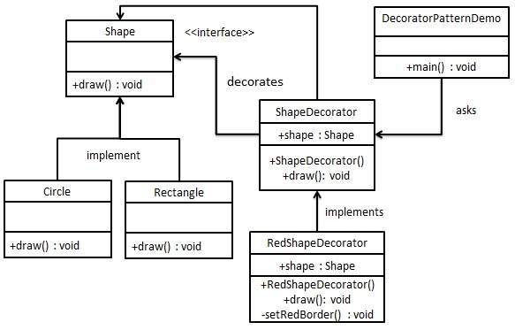

Step 1
Create an interface.
Shape.java
public interface Shape {
void draw();
}

Step 2
Create concrete classes implementing the same interface.
Rectangle.java
public class Rectangle implements Shape {

@Override
public void draw() {
System.out.println("Shape: Rectangle");
}
}
Circle.java
public class Circle implements Shape {

@Override
public void draw() {
System.out.println("Shape: Circle");
}
}

Step 3
Create abstract decorator class implementing the Shape interface.
ShapeDecorator.java
public abstract class ShapeDecorator implements Shape {
protected Shape decoratedShape;

public ShapeDecorator(Shape decoratedShape){
this.decoratedShape = decoratedShape;
}

public void draw(){
decoratedShape.draw();
}
}

Step 4
Create concrete decorator class extending the ShapeDecorator class.
RedShapeDecorator.java
public class RedShapeDecorator extends ShapeDecorator {

public RedShapeDecorator(Shape decoratedShape) {
super(decoratedShape);
}

@Override
public void draw() {
decoratedShape.draw();
setRedBorder(decoratedShape);
}

private void setRedBorder(Shape decoratedShape){
System.out.println("Border Color: Red");
}
}

Step 5
Use the RedShapeDecorator to decorate Shape objects.
DecoratorPatternDemo.java
public class DecoratorPatternDemo {
public static void main(String[] args) {

Shape circle = new Circle();

Shape redCircle = new RedShapeDecorator(new Circle());

Shape redRectangle = new RedShapeDecorator(new Rectangle());
System.out.println("Circle with normal border");
circle.draw();

System.out.println("\nCircle of red border");
redCircle.draw();

System.out.println("\nRectangle of red border");
redRectangle.draw();
}
}

Step 6
Verify the output.
Circle with normal border
Shape: Circle

Circle of red border
Shape: Circle
Border Color: Red

Rectangle of red border
Shape: Rectangle
Border Color: Red

Iterator Pattern
Iterator pattern is very commonly used design pattern in Java and .Net programming environment. This pattern is used to get a way to access the elements of a collection object in sequential manner without any need to know its underlying representation.
Iterator pattern falls under behavioral pattern category.

Implementation
We're going to create a Iterator interface which narrates navigation method and a Container interface which retruns the iterator . Concrete classes implementing the Container interface will be responsible to implement Iterator interface and use it
IteratorPatternDemo, our demo class will use NamesRepository, a concrete class implementation to print a Names stored as a collection in NamesRepository.
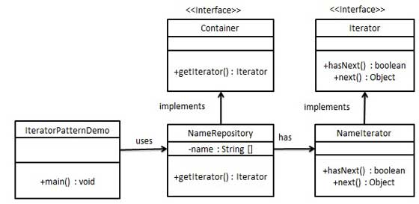

Step 1
Create interfaces.
Iterator.java
public interface Iterator {
public boolean hasNext();
public Object next();
}
Container.java
public interface Container {
public Iterator getIterator();
}

Step 2
Create concrete class implementing the Container interface. This class has inner class NameIterator implementing the Iterator interface.
NameRepository.java
public class NameRepository implements Container {
public String names[] = {"Robert" , "John" ,"Julie" , "Lora"};

@Override
public Iterator getIterator() {
return new NameIterator();
}

private class NameIterator implements Iterator {

int index;

@Override
public boolean hasNext() {
if(index < names.length){
return true;
}
return false;
}

@Override
public Object next() {
if(this.hasNext()){
return names[index++];
}
return null;
}
}
}

Step 3
Use the NameRepository to get iterator and print names.
IteratorPatternDemo.java
public class IteratorPatternDemo {

public static void main(String[] args) {
NameRepository namesRepository = new NameRepository();

for(Iterator iter = namesRepository.getIterator(); iter.hasNext();){
String name = (String)iter.next();
System.out.println("Name : " + name);
}
}
}

Step 4
Verify the output.
Name : Robert
Name : John
Name : Julie
Name : Lora

Mediator Pattern
Mediator pattern is used to reduce communication complexity between multiple objects or classes. This pattern provides a mediator class which normally handles all the communications between different classes and supports easy maintainability of the code by loose coupling. Mediator pattern falls under behavioral pattern category.

Implementation
We're demonstrating mediator pattern by example of a Chat Room where multiple users can send message to Chat Room and it is the responsibility of Chat Room to show the messages to all users. We've created two classes ChatRoom and User. User objects will use ChatRoom method to share their messages.
MediatorPatternDemo, our demo class will use User objects to show communication between them.
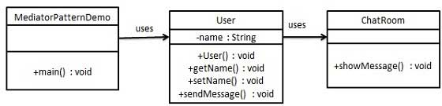

Step 1
Create mediator class.
ChatRoom.java
import java.util.Date;

public class ChatRoom {
public static void showMessage(User user, String message){
System.out.println(new Date().toString()
+ " [" + user.getName() +"] : " + message);
}
}

Step 2
Create user class
User.java
public class User {
private String name;

public String getName() {
return name;
}

public void setName(String name) {
this.name = name;
}

public User(String name){
this.name = name;
}

public void sendMessage(String message){
ChatRoom.showMessage(this,message);
}
}

Step 3
Use the User object to show communications between them.
MediatorPatternDemo.java
public class MediatorPatternDemo {
public static void main(String[] args) {
User robert = new User("Robert");
User john = new User("John");

robert.sendMessage("Hi! John!");
john.sendMessage("Hello! Robert!");
}
}

Step 4
Verify the output.
Thu Jan 31 16:05:46 IST 2013 [Robert] : Hi! John!
Thu Jan 31 16:05:46 IST 2013 [John] : Hello! Robert!

Observer Pattern
Observer pattern is used when there is one to many relationship between objects such as if one object is modified, its depenedent objects are to be notified automatically. Observer pattern falls under behavioral pattern category.

Implementation
Observer pattern uses three actor classes. Subject, Observer and Client. Subject, an object having methods to attach and de-attach observers to a client object. We've created classes Subject, Observer abstract class and concrete classes extending the abstract class the Observer.
ObserverPatternDemo, our demo class will use Subject and concrete class objects to show observer pattern in action.
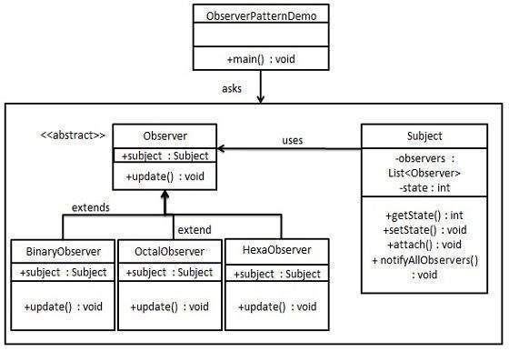

Step 1
Create Subject class.
Subject.java
import java.util.ArrayList;
import java.util.List;

public class Subject {

private List<Observer> observers
= new ArrayList<Observer>();
private int state;

public int getState() {
return state;
}

public void setState(int state) {
this.state = state;
notifyAllObservers();
}

public void attach(Observer observer){
observers.add(observer);
}

public void notifyAllObservers(){
for (Observer observer : observers) {
observer.update();
}
}
}

Step 2
Create Observer class.
Observer.java
public abstract class Observer {
protected Subject subject;
public abstract void update();
}

Step 3
Create concrete observer classes
BinaryObserver.java
public class BinaryObserver extends Observer{

public BinaryObserver(Subject subject){
this.subject = subject;
this.subject.attach(this);
}

@Override
public void update() {
System.out.println( "Binary String: "
+ Integer.toBinaryString( subject.getState() ) );
}
}
OctalObserver.java
public class OctalObserver extends Observer{

public OctalObserver(Subject subject){
this.subject = subject;
this.subject.attach(this);
}

@Override
public void update() {
System.out.println( "Octal String: "
+ Integer.toOctalString( subject.getState() ) );
}
}
HexaObserver.java
public class HexaObserver extends Observer{

public HexaObserver(Subject subject){
this.subject = subject;
this.subject.attach(this);
}

@Override
public void update() {
System.out.println( "Hex String: "
+ Integer.toHexString( subject.getState() ).toUpperCase() );
}
}

Step 4
Use Subject and concrete observer objects.
ObserverPatternDemo.java
public class ObserverPatternDemo {
public static void main(String[] args) {
Subject subject = new Subject();

new HexaObserver(subject);
new OctalObserver(subject);
new BinaryObserver(subject);

System.out.println("First state change: 15");
subject.setState(15);
System.out.println("Second state change: 10");
subject.setState(10);
}
}

Step 5
Verify the output.
First state change: 15
Hex String: F
Octal String: 17
Binary String: 1111
Second state change: 10
Hex String: A
Octal String: 12
Binary String: 1010

MVC Pattern
MVC Pattern stands for Model-View-Controller Pattern. This pattern is used to separate application's concerns.
- Model - Model represents an object or JAVA POJO carrying data. It can also have logic to update controller if its data changes.
- View - View represents the visualization of the data that model contains.
- Controller - Controller acts on both Model and view. It controls the data flow into model object and updates the view whenever data changes. It keeps View and Model separate.

Implementation
We're going to create a Student object acting as a model.StudentView will be a view class which can print student details on console and StudentController is the controller class responsible to store data in Student object and update view StudentView accordingly.
MVCPatternDemo, our demo class will use StudentController to demonstrate use of MVC pattern.
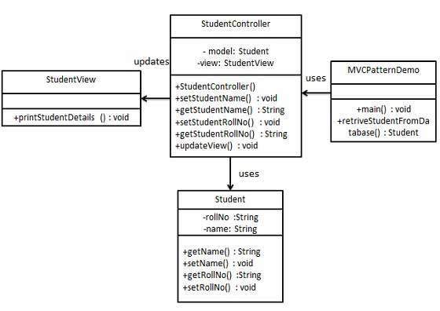

Step 1
Create Model.
Student.java
public class Student {
private String rollNo;
private String name;
public String getRollNo() {
return rollNo;
}
public void setRollNo(String rollNo) {
this.rollNo = rollNo;
}
public String getName() {
return name;
}
public void setName(String name) {
this.name = name;
}
}

Step 2
Create View.
StudentView.java
public class StudentView {
public void printStudentDetails(String studentName, String studentRollNo){
System.out.println("Student: ");
System.out.println("Name: " + studentName);
System.out.println("Roll No: " + studentRollNo);
}
}

Step 3
Create Controller.
StudentController.java
public class StudentController {
private Student model;
private StudentView view;

public StudentController(Student model, StudentView view){
this.model = model;
this.view = view;
}

public void setStudentName(String name){
model.setName(name);
}

public String getStudentName(){
return model.getName();
}

public void setStudentRollNo(String rollNo){
model.setRollNo(rollNo);
}

public String getStudentRollNo(){
return model.getRollNo();
}

public void updateView(){
view.printStudentDetails(model.getName(), model.getRollNo());
}
}

Step 4
Use the StudentController methods to demonstrate MVC design pattern usage.
MVCPatternDemo.java
public class MVCPatternDemo {
public static void main(String[] args) {

//fetch student record based on his roll no from the database
Student model = retriveStudentFromDatabase();

//Create a view : to write student details on console
StudentView view = new StudentView();

StudentController controller = new StudentController(model, view);

controller.updateView();

//update model data
controller.setStudentName("John");

controller.updateView();
}

private static Student retriveStudentFromDatabase(){
Student student = new Student();
student.setName("Robert");
student.setRollNo("10");
return student;
}
}

Step 5
Verify the output.
Student:
Name: Robert
Roll No: 10
Student:
Name: Julie
Roll No: 10

SIMPLE CODE: FIND THE WORD THAT IS MOST REPEATED IN A STRING ARRAY IN o(N).

Try this,
public class DuplicateWordSearcher {
@SuppressWarnings("unchecked")
public static void main(String[] args) {

String text = "a r b k c d se f g a d f s s f d s ft gh f ws w f v x s g h d h j j k f sd j e wed a d f";

List<String> list = Arrays.asList(text.split(" "));

Set<String> uniqueWords = new HashSet<String>(list);
for (String word : uniqueWords) {
System.out.println(word + ": " + Collections.frequency(list, word));
}
}

This can be done in O(n) time
Solution 1:
Steps:
- Count words and hash it, which will end up in the structure like this
- var hash = {
- "I" : 13,
- "like" : 3,
- "meow" : 3,
- "geek" : 3,
- "burger" : 2,
- "cat" : 1,
- "foo" : 100,
- ...
- ...
- Traverse through the hash and find the most frequently used word (in this case "foo" 100), then create the array of that size
- Then we can traverse the hash again and use the number of occurrences of words as array index, if there is nothing in the index, create an array else append it in the array. Then we end up with an array like:
- 0 1 2 3 100
- [[ ],[ ],[burger],[like, meow, geek],[]...[foo]]
- Then just traverse the array from the end, and collect the k words.

import java.util.HashMap;

/**
* Created with IntelliJ IDEA.
* User: Alexander.Iljushkin
* Date: 23.10.13
* Time: 11:32
*/
public class TestClass1 {

public static void main(String[] args) {
String[] football_club = {"Barcelona", "Real Madrid", "Chelsea", "Real Madrid", "Barcelona", "Barcelona"};
HashMap<String, Integer> map = new HashMap<String, Integer>();
String tempStr;
for (int i = 0; i < football_club.length; i++)
{
tempStr = football_club[i];
if(map.containsKey(tempStr))
{
map.put(tempStr, map.get(tempStr) + 1);
}
else
{
map.put(tempStr,1);
}
}

System.out.print(map.toString());
}
}

